**Lab 3 - Using the Azure Portal**

Pre-requisites:

* CloudLabs & Azure subscriptions (Email from Cloud Labs)

**Task 1: Explore the Azure Portal**

Click on Launch Lab and after the setup you will get username and password to login in Azure portal.

Use provided link to login on Azure portal and you are able to do the Lab3.

**Task 2: Provision an Azure SQL Database**

Log into the Azure portal

Locate the search box at the top of the page, and type in ‘SQL Database’

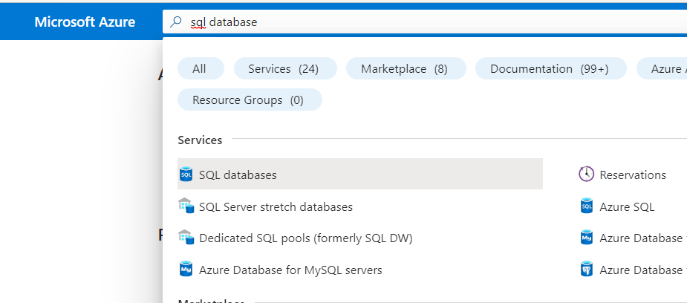

Click **SQL Databases** under the Services

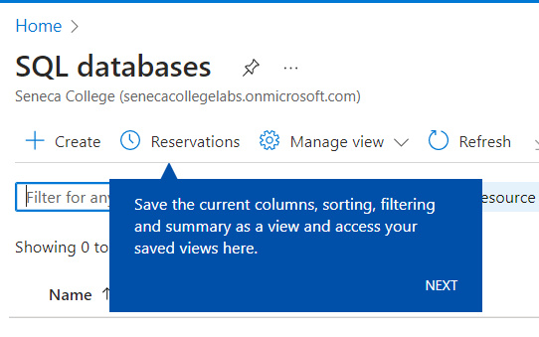

Click plus **‘+’ Create**

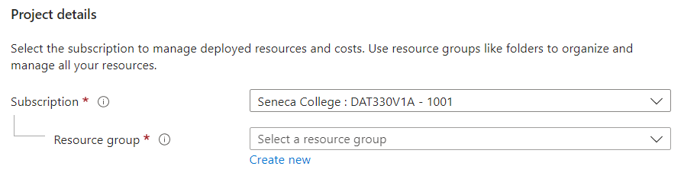

Select a subscription from drop down list if you have multiple subscriptions

Click **Create new** below Resource Group, and name the resource group with your choice

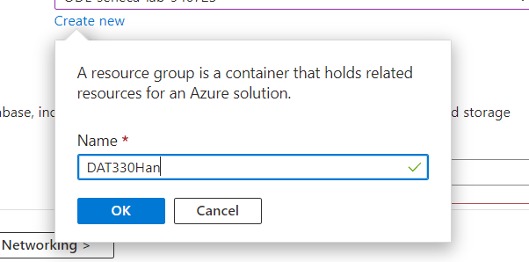

Click **OK** button to create a resource group

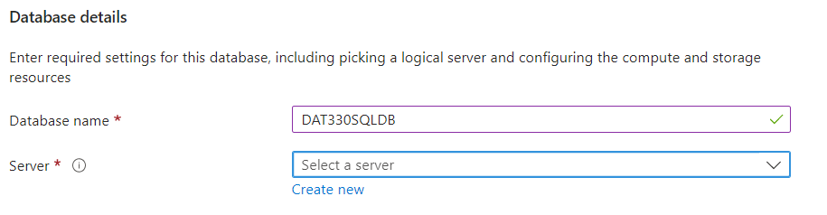

Enter a name with your choice, and click **Create new** under Server

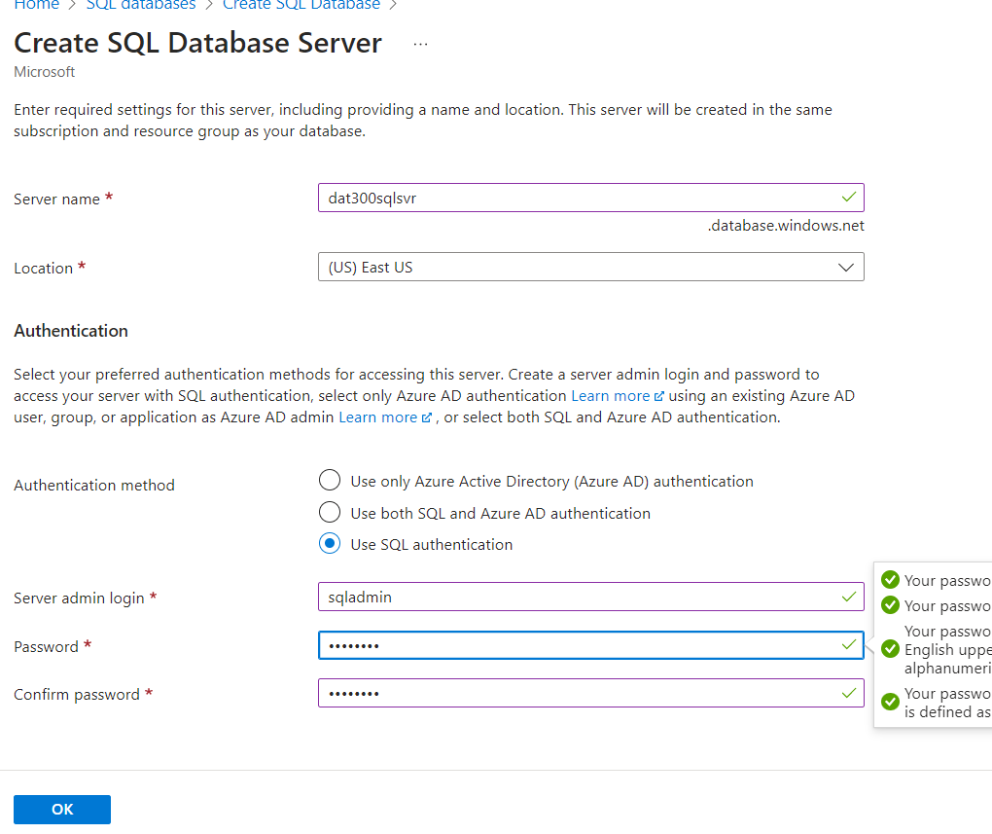

Fill out required information, and click **OK**

* Server name: your choice
* Location: select from the drop list
* Authentication method: Use SQL authentication
* Password: your choice

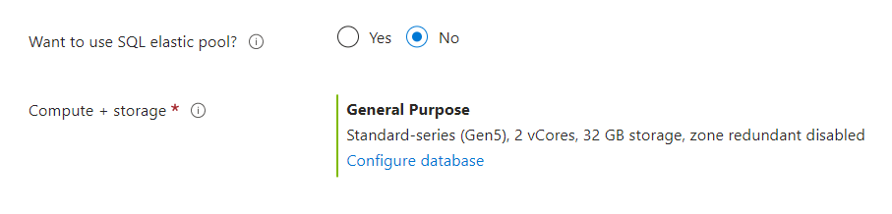

Select No from Want to use SQL elastic pool?

Click **Configure database**

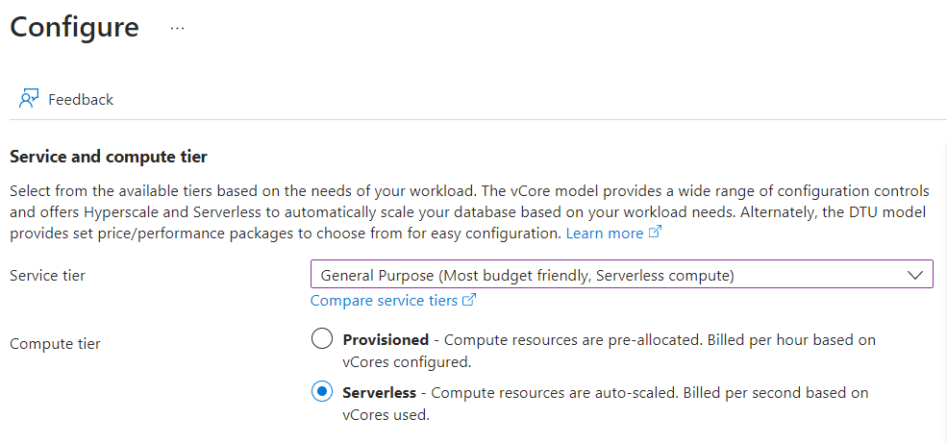

Select **General Purpose…** from drop down list and **Serverless** next to Compute tier

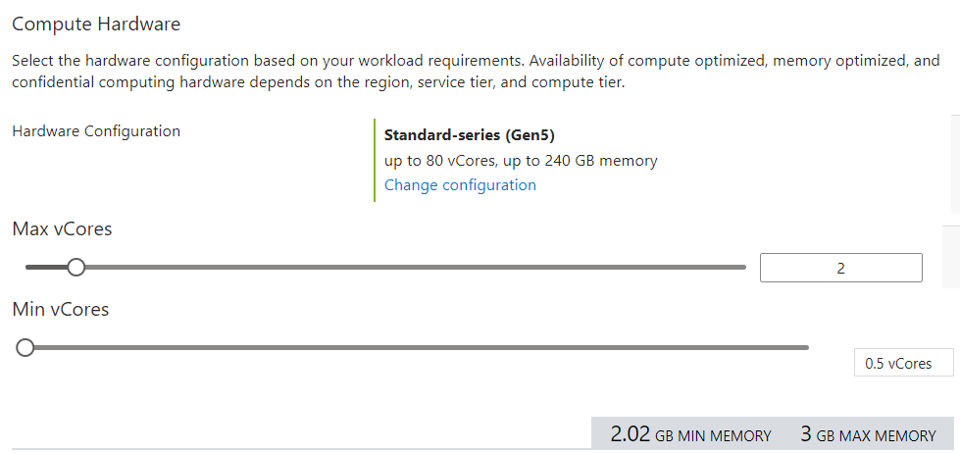

Leave default and you can explore more options by click **Change configuration**

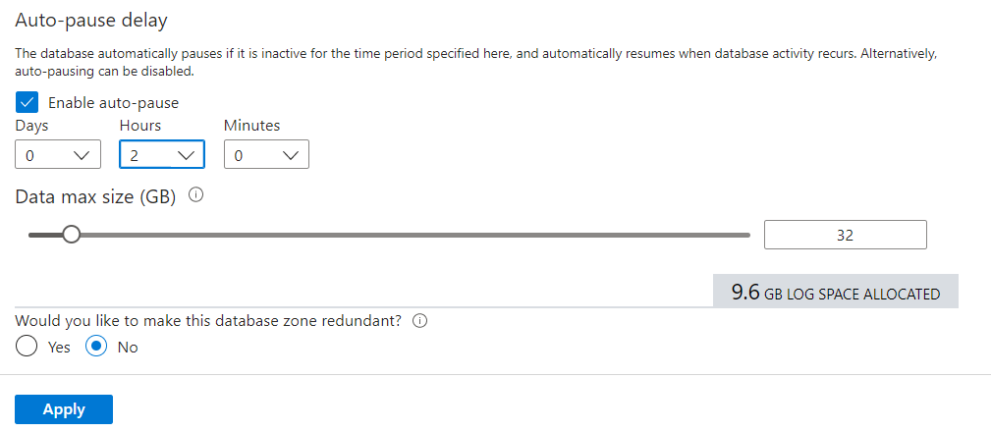

Select 2 Hours under Auto-pause delay, and click **Apply**

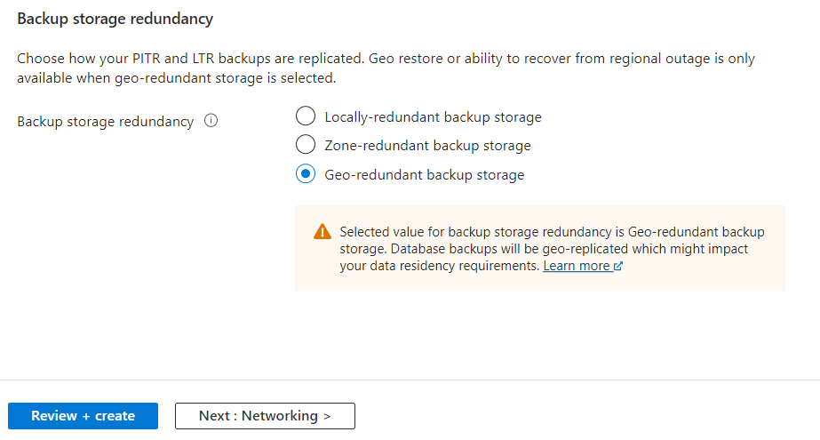

Leave as the default, and click **Review + create**

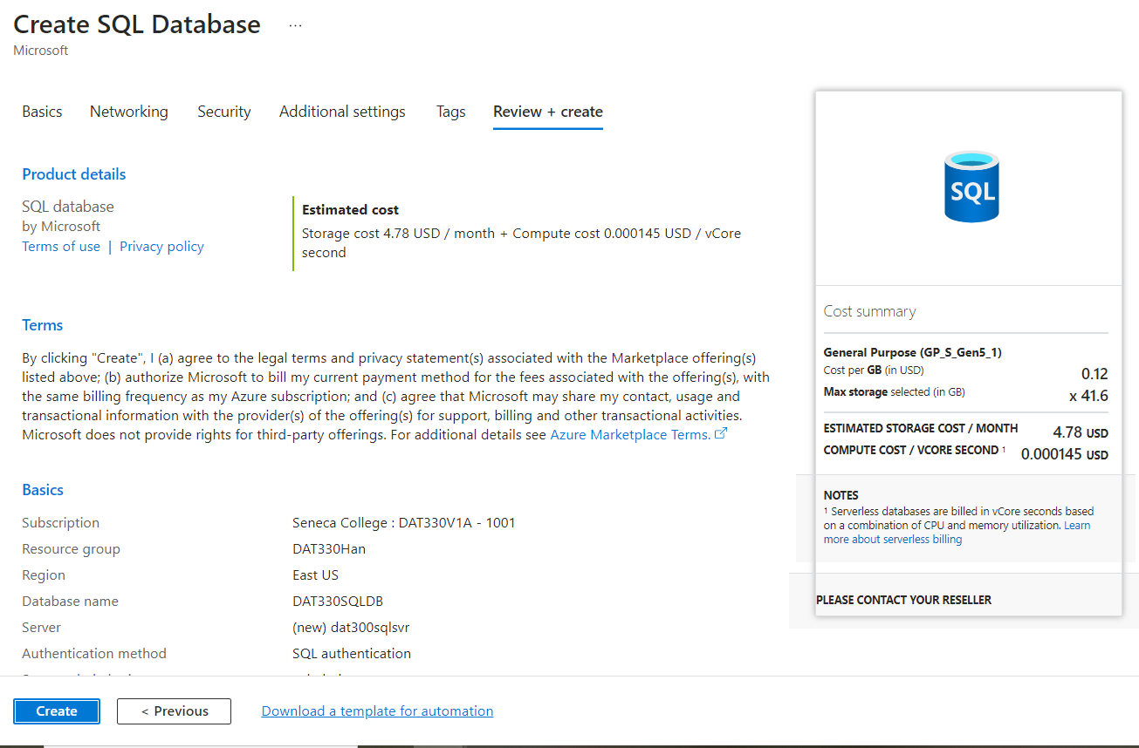

Review the summary and click **Create**

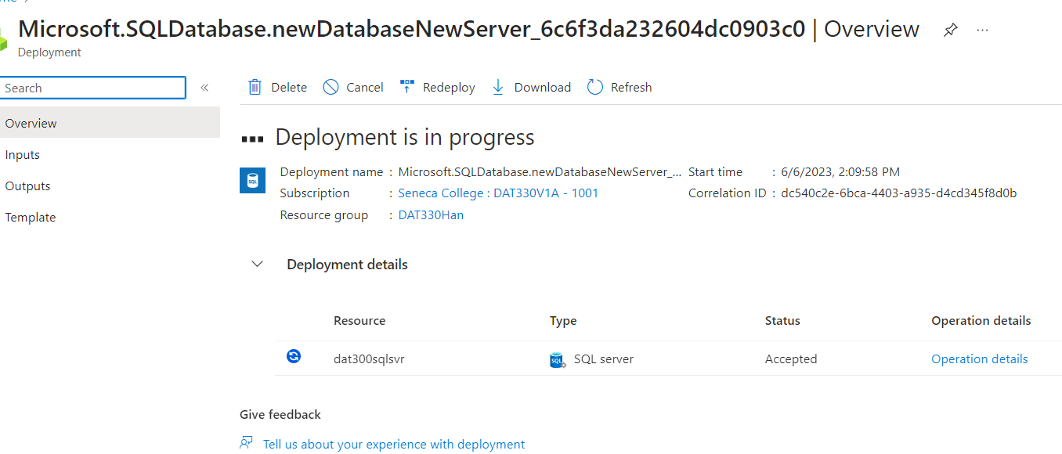

Monitoring the deployment process

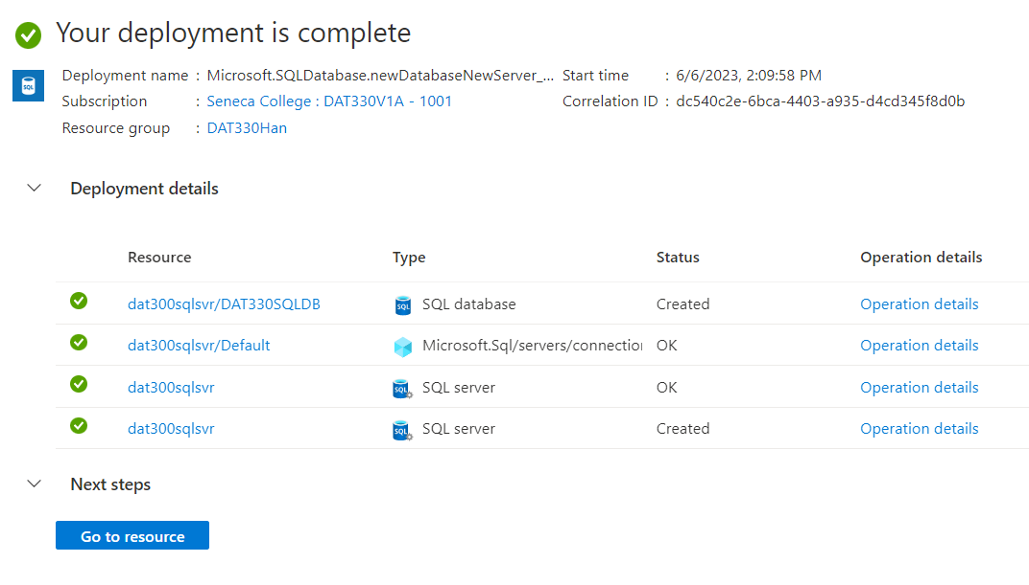

Once the deployment complete, click **Go to resource**

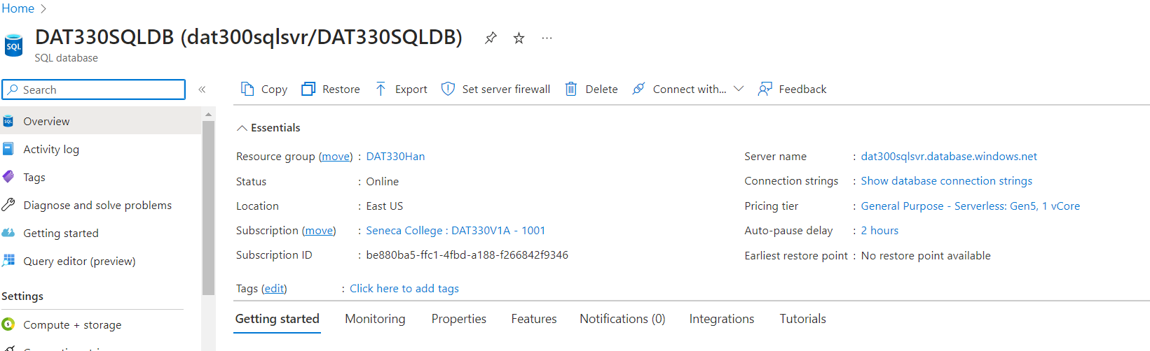

You can check what you have provisioned by clicking **Home**

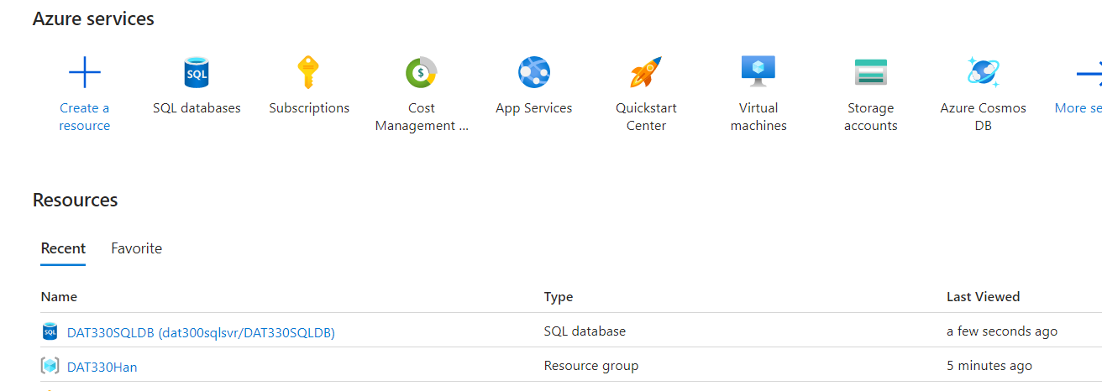

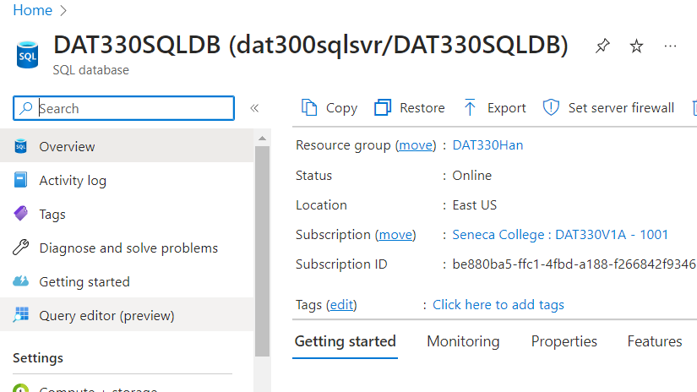

Click **Query editor (preview)** from SQL database page

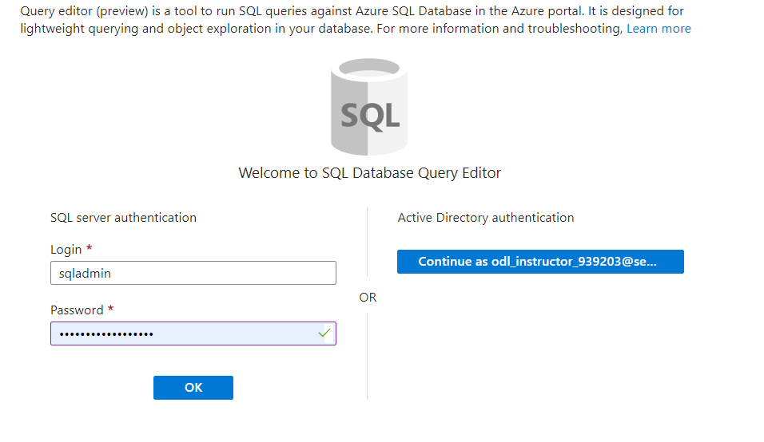

Click **OK**

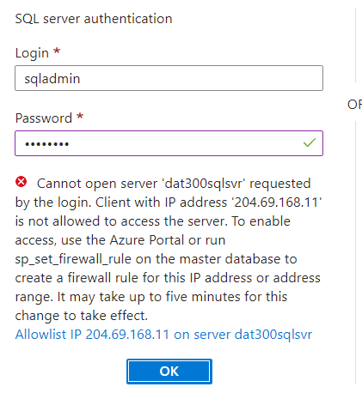

Click **Allowlist IP …** to add your external IP to the firewall, then click OK again

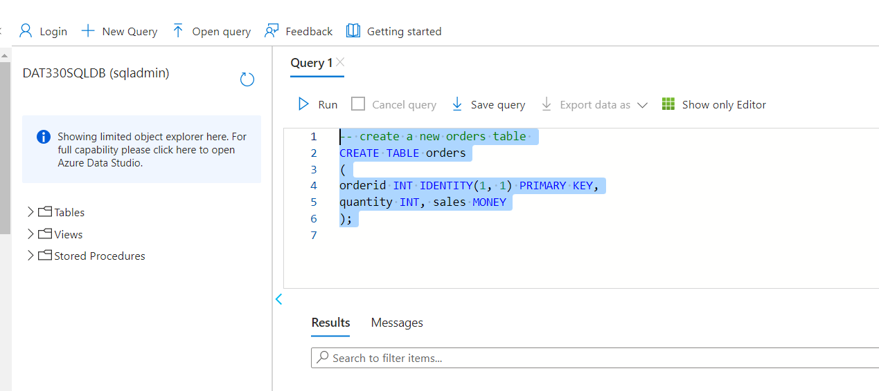

Create a table with the following statement by copy and paste to the editor and click **Run**

-- create a new orders table

CREATE TABLE orders

(

orderid INT IDENTITY(1, 1) PRIMARY KEY,

quantity INT, sales MONEY

);

--populate Orders table with sample data

;

WITH t1

AS (SELECT 1 AS a UNION ALL

SELECT 1),

t2

AS (SELECT 1 AS a FROM t1

CROSS JOIN t1 AS b),

t3

AS (SELECT 1 AS a FROM t2

CROSS JOIN t2 AS b),

t4

AS (SELECT 1 AS a FROM t3

CROSS JOIN t3 AS b),

t5

AS (SELECT 1 AS a FROM t4

CROSS JOIN t4 AS b),

nums

AS (SELECT Row_number()

OVER (

ORDER BY (SELECT NULL)) AS n

FROM t5)

INSERT INTO orders SELECT n,

n * 10

FROM nums;

GO

SELECT TOP 10 * from orders;

GO

Launch the SQL Server Management Studio

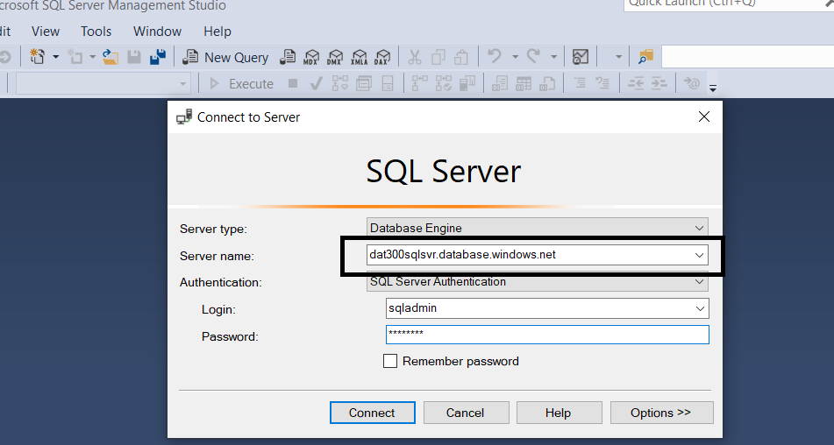

Fill out required information, and click **Connect**

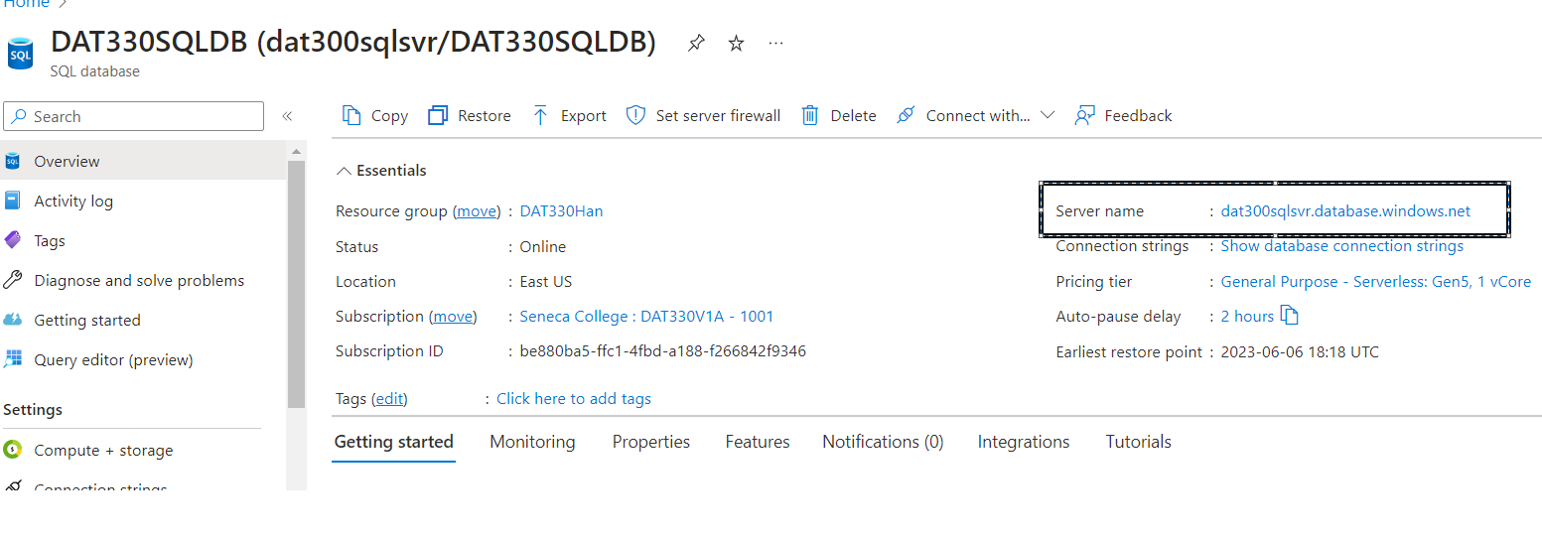

You can find **Server name** from Azure portal Database page

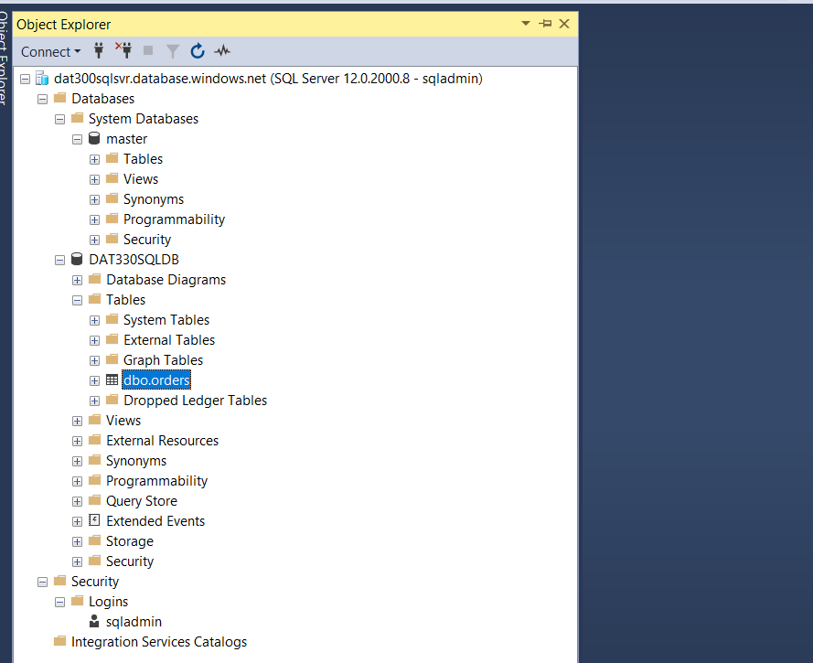

You can see the table created from previous steps and run queries against it